4.8.5 NIAE Quarterly
NIAE Quarterly
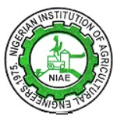
NATIONAL NEWS
NIAE QUARTERLY
VOL 3. No. 1 (ISSN 0794 – 8387) MAY, 2026
NATIONAL SPOTLIGHT



PROF. MAKANJUOLA’S 90TH LECTURE: FG SAYS MECHANIZATION, SAPZ KEY TO FOOD SOVEREIGNTY
The Federal Government has stated that agricultural mechanization and the Special Agro-Industrial Processing Zone, SAPZ, are critical to achieving national food sovereignty
The Minister of Agriculture and Food Security, Sen. Abubakar Kyari, made this known during the Prof. Gabriel Ayodele Makanjuola Lecture Series (GAMALS), held recently at Obafemi Awolowo University, OAU, Ile-Ife in Osun State.
The lecture, themed “Honouring the Nigerian Forerunner of Agricultural Engineering at 90: Legacy, Leadership and the Future of Agricultural Transformation”, marked the 90th birthday of Prof. Makanjuola.
Kyari highlighted that under the Renewed Hope Agenda of President Bola Tinubu, “mechanization is no longer optional. It is now an instrument of economic sovereignty.”
He added: “Agricultural engineering is no longer merely a supporting discipline. It is a strategic pillar of national transformation. But mechanization carries it forward. Not for the large estate alone, but scaled to the hands of the smallholder. These are the men and women who feed this nation, and they are who our strategy must reach.”
According to the Minister, “We celebrate an idea powerful enough to shape generations. It is the celebration of a man who did not wait for the future of agricultural engineering to arrive before he built it.”
“We gather in this great citadel of learning to salute a national pathfinder, pacesetter and trailblazer whose ideas helped engineer Nigeria’s agricultural modernization journey and whose classroom became a training ground for global leaders.”
Kyari noted that the life of the nonagenarian shows that nations are not transformed by policy declarations alone but by “people whose imagination breeds innovation, whose research breeds industry and whose teaching breeds leadership”, adding that the professor’s “story is a proof of concept that enduring greatness is built not by visibility but by utility.”
He revealed that the Professor’s work proved that “technology becomes transformational only when it reduces human drudgery, improves productivity, creates wealth, and restores dignity.”
Kyari cited Makanjuola’s innovations in food processing, agricultural machinery and post-harvest engineering, including yam pounding machines that earned three British patents. “When a Nigerian professor’s innovation earns three British patents, it is proof that African professors can produce world-class solutions,” he said.
“Prof. Makanjuola is an Iroko tree that became a forest. He laid the intellectual and professional foundations that elevated agricultural engineering into a recognized force for national development. The nation honoured that work with the Nigerian National Order of Merit, and he became one of the foremost architects of the Nigerian Institution of Agricultural Engineers (NIAE),” Kyari added.
He listed the administration’s priorities to include “expand agricultural mechanization, accelerate agro-industrialization, increase value addition and scale digital agriculture.”
“Nowhere is this clearer than in the Special Agro-Industrial Processing Zone, SAPZ, programme, where all of these priorities converge,” he stressed.
The Minister said SAPZ “brings agro-processing directly to where our farmers produce” and “is a flagship programme in Africa,” adding that the programme converts “our raw harvests into finished value.”
“Our mission is not simply to grow more food. It is to build a resilient, tech-driven agricultural economy. A Nigeria that feeds itself on its own terms, controls its own food future, and trades with the world from a position of strength,” Kyari added.
While calling on young engineers to emulate Prof. Makanjuola, the Minister said, “Study Prof. Makanjuola as a model. He did not chase recognition. Recognition followed relevance. He did not inherit institutions. He built them.
“Nigeria’s next agricultural engineering revolution requires builders of that caliber. Do not chase the applause; chase the impact. On behalf of the Government and people of the Federal Republic of Nigeria, I salute this legendary son of Nigeria.” He concluded
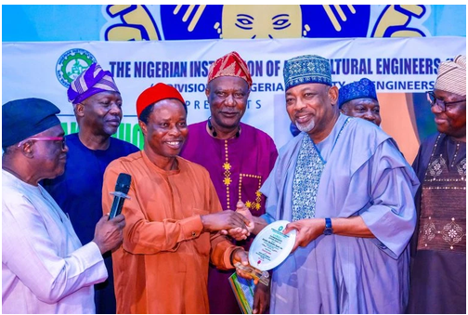
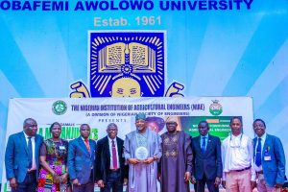

NATIONAL CHAIRMAN COURTESY CALL TO THE MINISTER OF AGRICULTURE AND RURAL DEVELOPMENT

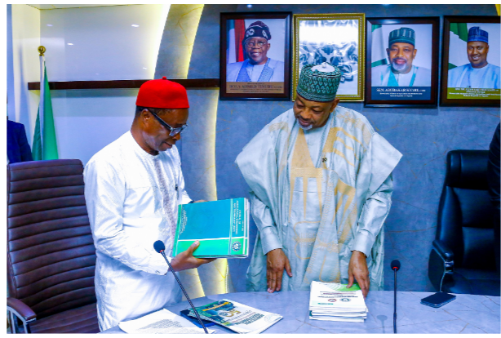
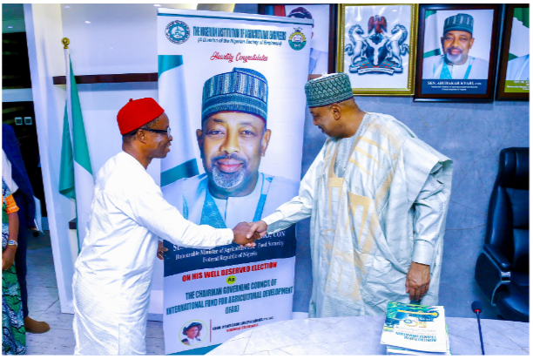
The National Chairman of the Nigerian Institution of Agricultural Engineers, Engr. Prof Joseph Adama led a team of members of Nigerian Institution of Agricultural Engineers to pay a courtesy visit to the Honourable Minister of Agriculture and Food Security, Senator Abubakar Kyari, CON.
The visit is to:
1. Appreciate Honourable Minister for his unwavering support to NIAE.
2. To brief him on achievements of the institution, role of agricultural mechanization in providing food sufficiency, upgrade of NCAM, recruitment of agricultural engineers into the ministry and agencies in the federal ministry of agriculture and food security, control interlopers in agricultural engineering jobs and positions.
3. To formally congratulate him on his election as the Chairman Governing Council of the International Fund for Agricultural Development (IFAD).
Elders and NEC and Members of the Institution who graciously attended the Courtesy Visit are:
1. Engr. Prof S. Z. Abubakar, President of COREN.
2. Engr. Ademola Olorunfemi, Past President, NSE and Chairman G. A. Makanjuola Lecture Series
3. Engr. Prof Joshua O. Olaoye, Immediate Past Chairman, NIAE.
4. Engr. Prof M. S. Abubakar, National Vice Chairman, NIAE
5. Engr. Francis Adole, Director DRD
6. Engr. Dr. Taiye Tehinse, Director, DRD
7. Engr. Dr. Molaruf Ajenifuja, Director, Mechanization Federal Ministry of Agriculture and Food Security, Abuja
8. Engr. Wale Okunade, MD, AEES, Ltd
9. Engr. Mrs Fati Baba Ahmed, Federal Ministry of Water Resources and Sanitation
10. Engr. Dr. Isaac Tanam, Vice President ISTRO Nigeria.
11. Engr. Bitrus Elesa, Chairman NIAE Committee of Tractors, implements, mechanics and operators.
12. Engr. Titilayo OLADELE, Admin Officer, NIAE.
The Honourable Minister thanked NIAE for the visit. He stated that all the issues as presented are pertinent, and the ministry will collaborate, support and pursue them.

The Hon. Minister graciously accepted to be the Lecturer for the maiden edition of the G. A. Makanjuola Lecture Series.
Also, the Honourable Minister commended the plan by the Institution to institute an award for the best performing governor on Agricultural Mechanization in Nigeria.
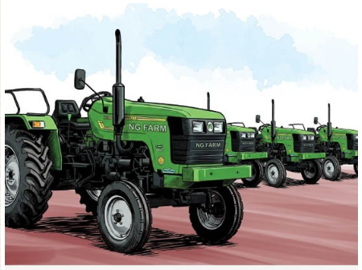
Most federal government’s tractors and other agricultural equipment aimed at boosting mechanisation have not reached farmers, 11 months after the presidential launch in Abuja.
A total of 2,000 tractors were acquired under the federal government’s Renewed Hope National Agricultural Mechanisation Programme, which was supported by a N50 billion catalytic seed fund from the Bank of Industry.

In June 2025, during the launch of the equipment, President Bola Ahmed Tinubu said the country’s collaboration with Belarus resulted in the delivery of the 2,000 state-of-the-art tractors, 10 combined harvesters, 12 mobile workshops and 9,000 agricultural tools, along with essential spare parts.
Projected outcomes include the cultivation of over 550,000 hectares of farmland, production of more than 2 million metric tonnes of staple food, creation of over 16,000 jobs and direct benefits to over 550,000 farming households.
However, most of the tractors remained at the premises of the National Agricultural Seeds Council, Sheda, along the Abuja-Lokoja expressway, still waiting for disbursement since they were supplied over a year ago.
Seven months after the presidential launch, the Federal Ministry of Agriculture and Food Security bowed to public pressure to flag off the distribution of the tractors to beneficiaries, said to be drawn from the six geopolitical zones of the country.
The Minister of Agriculture and Food Security, Senator Abubakar Kyari, said the first tranche of 600 tractors marked the beginning of a phased acceleration, adding: “This will be followed by 750 and 650 tractors, culminating in a nationwide force of 2,000 mechanisation assets.”
In the first phase of the distribution, the minister said thousands of applications were received.
“It is imperative to inform you that over 100,000 applications were received for this first phase alone,” he declared during the exercise.
Sources privy to the process said the Ministry of Agriculture was under significant pressure from multiple stakeholders including members of the parliament, state governors, prominent political figures and influential farmers’ organisations, as well as traditional rulers over the tractors.

Professor Adama Honoured at MOUAU Reception for National Leadership in Agricultural Engineering
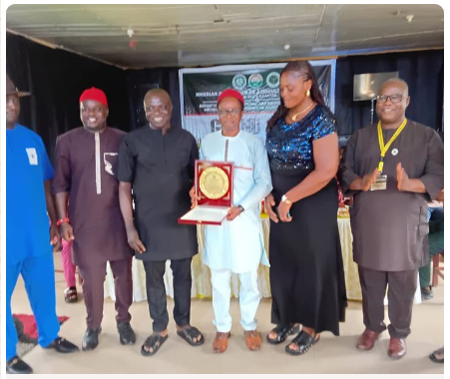
The Nigerian engineering community converged on the Michael Okpara University of Agriculture Umudike, Abia State, to honour Professor Joseph Chukwuma Adama following his emergence as National Chairman of the Nigerian Institution of Agricultural Engineers.
The reception, held at the university’s Alumni Secretariat in Umudike, was jointly organised by the Nigerian Institution of Agricultural Engineers and the Department of Agricultural and Biosystems Engineering of the university. The event attracted academics, traditional rulers, industry stakeholders and government officials who celebrated Professor Adama’s contributions to agricultural engineering and national development.
Professor Adama was formally inaugurated as National Chairman of NIAE in December 2025 after previously serving as National Vice Chairman from 2021 to 2023 and National Secretary between 2016 and 2021.
Speakers at the event described him as a disciplined administrator, scholar and mentor whose leadership had elevated the profile of agricultural engineering in Nigeria.
The Chairman of the organising committee and Abia State Chairman of NIAE, Udensi Kelvin Nnadozie, said Professor Adama’s achievements had brought pride to the university, the engineering profession and the country.
He noted that the new NIAE chairman had consistently demonstrated commitment to professional excellence, institutional growth and innovation in agricultural engineering practice.
Participants also commended Professor Adama for promoting digital transformation in agriculture and supporting collaboration with the Federal Ministry of Agriculture and Food Security to advance sustainable mechanised farming initiatives across the country.
In his remarks, Professor Adama urged engineers and other professionals to embrace integrity, loyalty and sacrifice in the discharge of their responsibilities, stressing that sustainable national development depended on ethical leadership and professional discipline.
Reflecting on his journey in the institution since 1997, he recounted years of perseverance and acknowledged the role played by mentors and colleagues in shaping his career within the engineering community.
He also disclosed that a committee had been established to address concerns over the activities of unqualified individuals allegedly engaging in professional agricultural engineering practice.
Among dignitaries who spoke at the event were Taiye Tehinse and HRH Eze S O Ugwu, who commended Professor Adama’s leadership qualities and pledged support for his administration.
The occasion also featured the inauguration of newly elected executives of the Abia State chapter of NIAE, while former state chairman, Victor Ihediwa, presently Chairman of NIAE, South-east region and Engr Prof M. Ndukwu, as ex officio 1 & 2 member of the executive council.
Observers described the gathering as a reflection of the growing recognition of agricultural engineering as a critical driver of food security, rural development and sustainable economic growth in Nigeria.
Members of the newly inaugurated NIAE Abia State chapter executive are as follows:
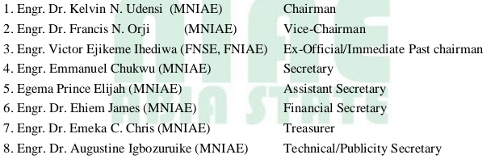

Think Tank of leading professionals from all branches of Engineering in Nigeria and it provides leadership in promoting Science, Technology and Innovation in

POLITICAL NEWS
ZULUM DISTRIBUTES FARM TOOLS, IN DAMASAK

February Professional Development Webinar Series

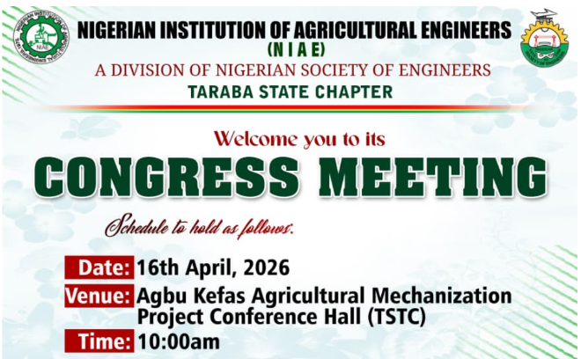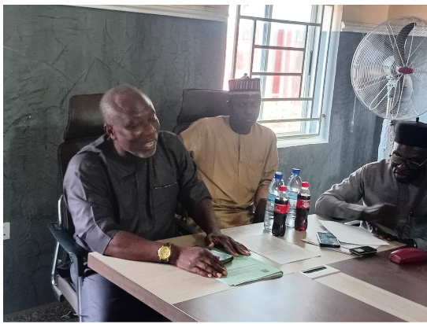
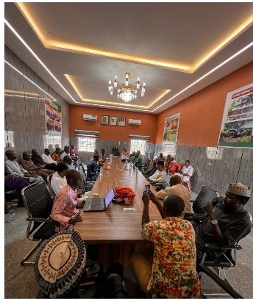
The Nigerian Institution of Agricultural Engineers in its monthly professional development webinar series for the month of February 2026 was presented by Engr.

NIAE KANO CHAPTER INAUGURATED

ABUJA CHAPTER OF NIAE GOT NEW EXCOs

The Abuja Chapter elected their new EXCOs after Engr. Adebayo Adedeji has finished his tenure with his team. The new EXCOs tenure would expire in 2028.
l sessions

PROMOTION

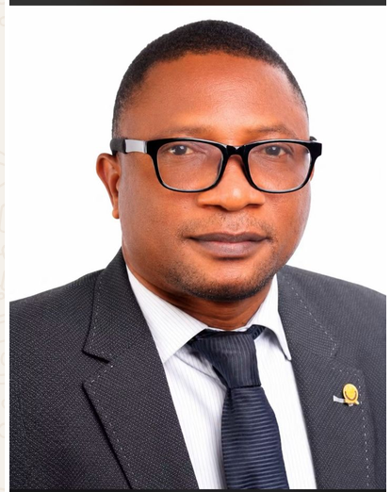
Professor Timothy Adekanye
The Governing Council of Osun State University, at its meeting, has approved the promotion of Engr. Dr. Wasiu Agunbiade Lamidi to the rank of Professor, making him the first Professor of Agricultural and Biosystems Engineering in the University.

This remarkable achievement is a testament to his years of dedication, academic excellence, impactful research, professional distinction, and concerted commitment to the advancement of engineering education and scholarship.

We join colleagues, students, alumni, friends, and well-wishers in celebrating this historic milestone. His elevation not only brings pride to the Department and the Faculty but also marks a significant step forward in the growth and development of Agricultural and Biosystems Engineering at the University.
We heartily congratulate our pioneer Professor on this well-deserved honour and noble achievement. We pray for greater accomplishments, good health, wisdom, and continued success as he continues to contribute to the advancement of knowledge, innovation, and national development.

Congratulations, Prof. Wasiu Agunbiade Lamidi
Wishing you many more years of impactful service and academic excellence.

Dr. Udom was born in 1964 at Ikot Akpan Afaha, Ukanafun LGA, Akwa Ibom State, Nigeria. He holds a PhD degree in Agricultural Engineering(Soil & Water Resources Engineering) from the University of Nigeria Nsukka. He was the Director of School of Engineering, Akwa Ibom State College of Agriculture before an appointment at Akwa Ibom State University as the pioneer Acting Head of Department where he is presently a Senior Lecturer. His research interests are in the areas of water resources engineering, environmental engineering, constructed wetlands, and agricultural waste management.
The Governing Council of Akwa-State University has pronounced Ikpe Jimmy Udom a Professor today. This remarkable achievement is a testament to his hard work, dedication, academic excellence, and outstanding contributions to teaching, research, and community service. His elevation to the rank of Professor is not only a personal milestone but also an inspiration to colleagues, students, and the academic community at large.
May this new height bring him greater fulfilment, wisdom, and opportunities for more impactful service to humanity.
I wish him continued success, sound health, and greater accomplishments in all his future endeavours.
Congratulations once again.
WEDDING CEREMONY

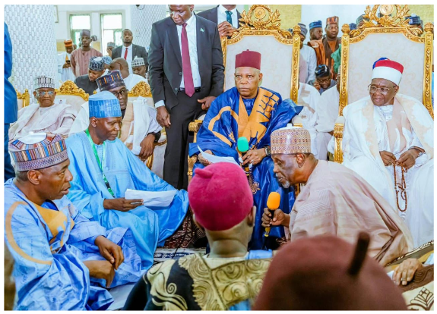

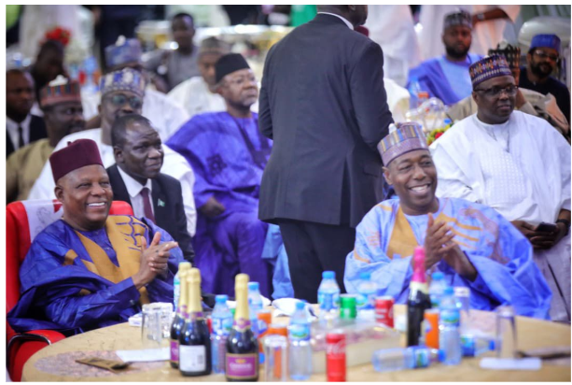

VP Shettima leads Speaker Abbas, others to wedding of Zulum’s children

Vice President Kashim Shettima on Saturday led the Speaker of the House of Representatives, Tajuddeen Abbas, several governors, National Assembly members, ministers, and other high-level dignitaries to the wedding of the children of Borno State Governor, Babagana Umara Zulum, in Maiduguri.

The children are Aisha Babagana Zulum, married to Mohammed Idi Barde; Mamman Babagana Zulum, who is married to Yagana Mustapha Busuguma; Umar Babagana Zulum, who is married to Fatima Azzaki Jidda, and Abba Abubakar Umara, who is married to Aisha Ibrahim Musa.

The wedding Fatiha took place at the Maiduguri Central Mosque around the palace of the Shehu of Borno, Abubakar Ibn Umar Garbai Al-Amin Elkanem.

The Vice President, Kashim Shettima, served as the ‘wali’ (bride’s representative) who gave out Aisha Babagana Umara Zulum as wife of Mohammed Idi Barde.

Notable personalities in attendance include former Vice President Babagana Kingibe; National Chairman of the All Progressives Congress (APC), Nentawe Yilwatda; Deputy Senate President, Jibril Barau; Alhaji Aliko Dangote; former governor of Borno State, Senator Ali Modu Sheriff; and the former minister of communication, Professor Isa Ali Pantami.

The governors present include those of Kwara, Ogun, Gombe, Yobe, Kebbi, Zamfara, Sokoto, Niger, Jigawa, Kano, Nasarawa, Katsina, and Kaduna states. At the same time, the governors of Imo and Oyo were represented by their deputies.

Others include the ministers of Agriculture, Budget and Economic Planning, Housing and Urban Development, Health and Social Welfare, Education, and the Minister of State for Regional Development. Also in attendance was the elder statesman, Dr Muhammadu Indimi and traditional rulers from across the country.

CONFERMENT OF NSE FELLOWS TO NIAE MEMBERS

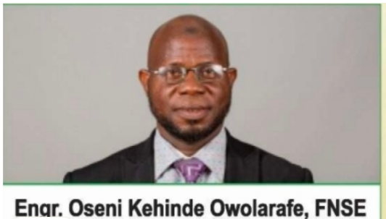

Congratulations on your conferment as a fellow of NSE.

NSE NATIONAL CONFERENCE

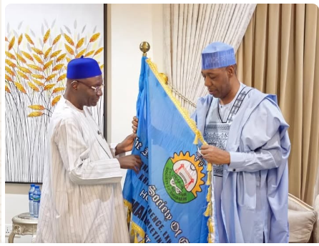

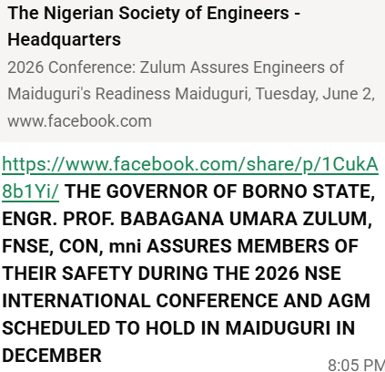
APPOINTMENTS OF NIAE MEMBERS
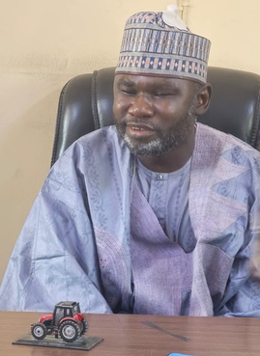

Engr Peter Samuel
Heartfelt congratulations to Engr. Peter Samuel on taking the mantle of leadership of Borno state Agricultural mechazation Authority (BOSAMA) today.

Your appointment is a well-deserved recognition of your dedication, competence, and commitment to excellence. We are confident that your leadership will bring progress, innovation, and greater achievements to BOSAMA.

May Almighty God grant you wisdom, strength, good health, and divine guidance as you lead the organization to greater heights.

Congratulations once again, and I wish you a successful and impactful tenure.

GOVERNOR SOLUDO APPOINTS PROFESSOR IFEANYI OBIORA NDIRIKA AS PROVOST OF NWAFOR ORIZU COLLEGE OF EDUCATION, NSUGBE
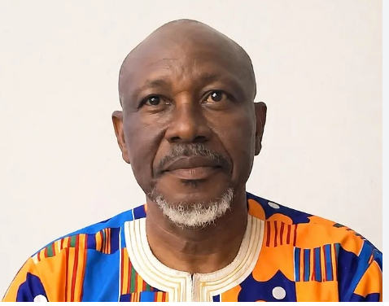
The Governor of Anambra State, Professor Chukwuma Charles Soludo, CFR, has appointed Professor Victor Ifeanyi Obiora Ndirika, a renowned Agricultural Engineer and eminent scholar, as the new Provost of Nwafor Orizu College of Education, Nsugbe.
Before his new appointment as provost, Professor Ndirika was a professor in the Department of Agricultural and Bioresources Engineering, Faculty of Engineering, Nnamdi Azikiwe University, Awka.
As a top-grade engineer, lecturer, administrator, and researcher who has authored numerous peer-reviewed papers and publications in reputable journals, Professor Ndirika brings much experience to his new role.
Professor Ndirika is expected to lead Nwafor Orizu College of Education to a whole new era of all-round excellence in producing world-class, modern teachers for Anambra State and beyond.

GOVERNOR SOLUDO APPOINTS AUST PRESIDENT, PROF ONWUALU, AS CHAIRMAN/PRO-CHANCELLOR OF COOU
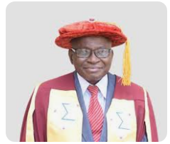
The Governor of Anambra State His Excellency, Governor Chukwuma Charles Soludo, CFR, has appointed the President of African University of Science and Technology, Professor Azikiwe Peter Onwualu, FAS, as Chairman and Pro-Chancellor of Chukwuemeka Odumegwu Ojukwu University.
The appointment, announced in an official press statement, has been widely welcomed as a well-deserved recognition of Professor Onwualu’s outstanding contributions to academia, engineering, and national development. It also signals a renewed commitment to excellence in the governance of the state-owned university.
Joining him on the Governing Council are Chief Christopher Ndubuisi, HRH Igwe Chidiume Oranu, Professor Josephat O. Ogbuagu, and AIG (Rtd.) Sir Chris Ezike individuals whose diverse expertise is expected to further enrich the institution’s leadership.
Professor Onwualu brings to the role a remarkable wealth of experience. A respected Professor of Agricultural Engineering at the University of Nigeria Nsukka, he has distinguished himself as both a scholar and a visionary leader. His career spans several high-impact roles, including Director-General and Chief Executive Officer of the Raw Materials Research and Development Council and senior leadership positions at the National Agency for Science and Engineering Infrastructure.
At AUST, he has been instrumental in driving innovation, strengthening academic standards, and positioning the university as a hub for science, technology, and research in Africa. His earlier roles within the institution as Head of Department and Director of Academic Planning further underscore his deep commitment to educational advancement.
A Fellow of numerous professional bodies, including the Nigerian Academy of Engineering and the Nigerian Academy of Science, Professor Onwualu is also a former President of the Nigerian Academy of Engineering. With over 200 scholarly publications, multiple patents, and more than 70 awards to his name, his achievements continue to inspire both colleagues and students alike.
Governor Soludo expressed strong confidence that under Professor Onwualu’s leadership, the Governing Council will usher in a new era of growth, innovation, and academic excellence at Chukwuemeka Odumegwu Ojukwu University.
The appointment is not only a proud moment for African University of Science and Technology but also a significant boost for higher education in Nigeria, as stakeholders look forward to the positive transformation his leadership is expected to bring.

